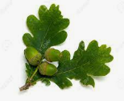
Oak Class Homework Grid Spring Term
Choose at least one activity per week to complete as your homework. Make sure that you are choosing activities from different subjects each week. Please complete your work in your homework book. If you complete work on the computer or it involves cooking or drawing then you can either print it out and stick in, or take a photograph to print out and then stick it in. If you do not have a printer, then you can still email, oak@bentfield.essex.sch.uk and we can print it out at school. I look forward to seeing what you come up with!
Reading | Writing | Maths | Science | Wider curriculum
Choose a character from the book you are reading to create a one-page fact file about. Include:  - What they look like  - Their personality  - Whether you like the character or not and why  - A picture of them  - Use the information from the text to make your profile as accurate as possible. | 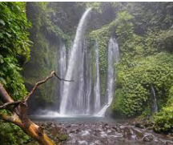  Write a story, using this image as a starting point. Imagine some characters in this place to help you. Your story should be a page of A4. Include:  - Accurate punctuation  - A balance between speech, action and description  - Descriptive language such as adjectives, adverbs, similes and metaphors. | https://corbettmathsprimary.com/content/  Visit the web address above. You will see a list of maths topics. Click on the questions for a topic that you think you could do with some more practice at. Then have a go at these questions. You can print them out or just work out the answers in your book, remembering to show all of the calculations that you have done and making your final answer clear, using units of needed.  This is the only maths task, but you can complete it multiple times with multiple topics. | Classification Keys  Make a classification key that could be used to classify something of your choice. This could be famous people, Pokémon, sports teams or anything of your choice. The skill you are working on is making the key itself.  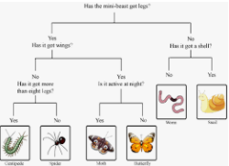 | History  Research interesting facts about the Mayan Civilisation. Make an information sheet about that period of history that would be exciting and interesting for an 11-year-old child to read. Include:  - Pictures with captions  - Interesting facts to draw the reader in  - Accurate punctuation  - Sub-headings for different sections
Write a book review for a book that you have finished reading. Include:  - Author  - What the book was mostly about  - The type of story it was  - Your favourite character and why?  - Your favourite part of the story and why? | 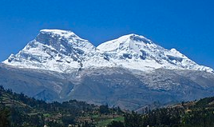  Write a descriptive poem about a mountain. You can use this picture to help you. It does not have to rhyme but can if you want it to. Include:  - Similes, metaphors and personification  - Your feelings about the mountain  - Similar numbers of syllables in each line of your poem  - At least 4 lines in each verse. (4 verses) |  | Carol Diagram  Pick 10 different animals. Make a Carroll diagram to sort these animals using your own categories. You can draw the animals in the diagram or write them down.  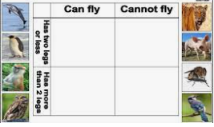 | ART  Make a pencil drawing of a Mayan statue. You could use the pictures below or research your own. You should concentrate on shading skills as you are using just pencil for this picture.  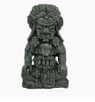  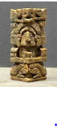
Choose 2 books that you have read and write a comparison between them. Include:  - Which did you like better and why?  - Who was your least favourite character and why you didn’t like them?  - A mark out of 10 for each book explain why you would or wouldn’t recommend them reading it. | Paddington Bear came from ‘deepest, darkest Peru’. Write a story of an animal from South America and their adventures. Include:  - Accurate punctuation  - A balance between speech, action and description  - Descriptive language such as adjectives, adverbs, similes and metaphors.  - A variety of sentence and clause types. |  | The Blood  Choose a type of blood cell: red, white, platelet, plasma.  Write an autobiography from the point of view of the blood cell. Start with what the blood cell is, what it does during its life span and how long it lives. You may need to do some research to help you with this task. | D&T  https://www.bbcgoodfood.co  m/recipes/Alfajores  Please note – leave out the cognac. Dulce de leche can be substituted for caramel.  Once you have made and tasted them, write down a review of how they taste in your book. This should be at least 5 sentences long.

