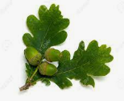
Oak Class Homework Grid Autumn Term
Choose at least one activity per week to complete as your homework. Make sure that you are choosing activities from different subjects each week. Please complete your work in your homework book. If you complete work on the computer or it is making a model etc., then you can print this out and stick in, or take a photograph to print out and stick it in. If you do not have a printer, then you can still email oak@bentfield.essex.sch.uk and we can print it out at school. I look forward to seeing what you come up with!
Reading | Writing | Maths | Science | Wider curriculum
Choose a character from the book you are reading and write a sentence for each of the points below:  1.What they look like  2. Their personality  3. Whether you like the character or not and why  4. A picture of them | 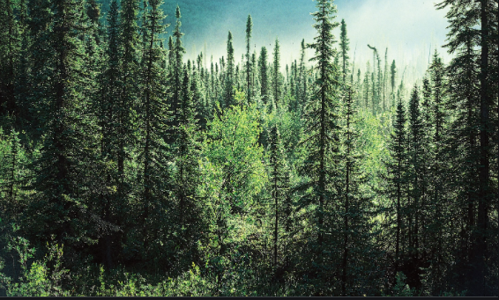  Write a story opening, describing the setting that you can see in the picture. You can imagine things that you can’t see as well! Make sure that you use adjectives to describe. You should write 3-5 sentences. | https://www.nytimes.com/puzzles/sudoku/easy  Have a go at this Sudoku puzzle. The digits 1 to 9 must be in every 3 x 3 square, every row and every column. Good luck! | Habitats  Choose a wild animal and think about where it lives, what it eats and what might try to eat it. Draw a picture of the animal in its natural environment and label the different parts to show what it eats, how it keeps itself safe and where it lives. | DT  Consider the effect humans have had on the Earth or plastic pollution in our seas. Choose one effect the create a model to illustrate how this looks in reality.
For a book that you have read recently, write 3 sentences to explain what happened at the beginning, middle and end of the story. | Choose an animal and research interesting facts about that animal. Write down 3 key facts about that animal in your own words. Remember your sentence punctuation! | https://www.topmarks.co.uk/maths-games/hit-the-button  Play the Hit the Button game to practise number bonds or times tables. Make sure to practise the ones you’re not sure about yet to get better. | Evolution  Charles Darwin came up with the theory of evolution.  Research about Charles Darwin and write down the 3 most interesting facts that you find. | Geography  Make a poster to encourage people to help people understand the impact of humans on the Earth.
Write a book review for a story that you have read or someone has read to you.  Write 3 sentences to explain:  1.If you liked the story or not.  2. Why you liked or didn’t like the story.  3. Whether you would tell someone else to read it or not and why | 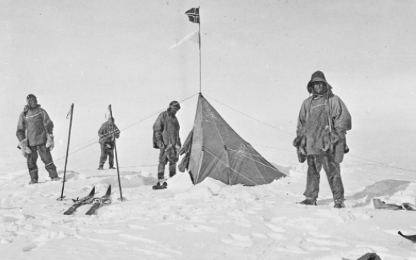  This picture is of an early exploration to the South Pole. They would have travelled for months in a ship and then by skis and sleds to get here. Write down 5 sentences about what this journey would have been like for them. | https://nrich.maths.org/7337  Find someone at home to play this game with. It is a bit like noughts and crosses, but using dice as well. Have a few goes and see who manages to win most games. | Evolution  Choose an animal. Draw a picture of what it looks like, then research what it looked like before it evolved into what it looks like now and draw a picture of this form as well. | ART  Think about the extreme weather conditions we have experienced in recent years!  Create a piece of artwork that symbolises your feelings towards the very high temperatures or very wet conditions. Consider your choice of colours carefully – which ones represent heat and warmth or wet and cloudy?

